* EBS stands for **Elastic Block Store**.
* EC2 is a virtual server in a cloud while EBS is a virtual
* disk in a cloud.
* Amazon EBS allows you to create storage volumes and attach them to the EC2 instances.
* Once the storage volume is created, you can create a file system on the top of these volumes, and then you can run a database, store the files, applications or you can even use them as a block device in some other way.
* Amazon EBS volumes are placed in a specific availability zone, and they are automatically replicated to protect you from the failure of a single component

EBS Volume Types:

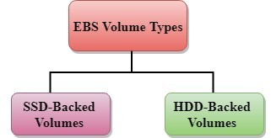

Amazon EBS provides two types of volume that differ in performance characteristics and price. EBS Volume types fall into two parts:

* SSD-backed volumes
* HDD-backed volumes

STEP1: create an instance in Ec2

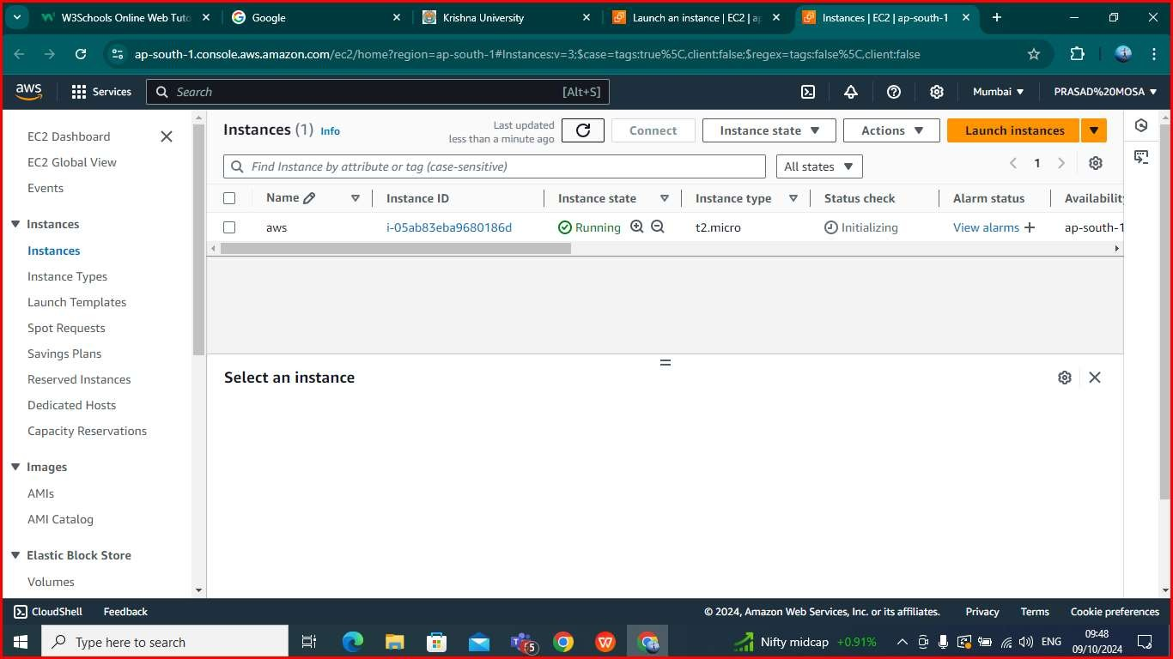

Step2: Attaching the created volume to the Ec2

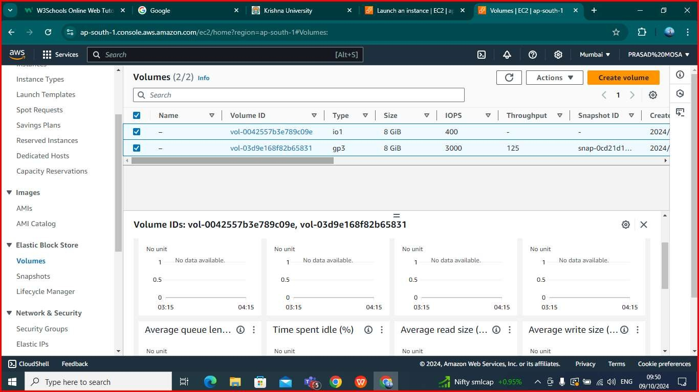

Volume will be created automatically when instance has been created

# Using Terraform

**Step1:**

provider "aws" { region = "ap-south-1"

}

resource "aws_instance" "First_Instance" { ami = "ami-078264b8ba71bc45e" instance_type = "t2.micro"

}

resource "aws_ebs_volume" "Terraform_Volume" { availability_zone = "ap-south-1a

size = 10

tags = {

Name = "Terraform_Volume

}

}

Here from the following code we can see that we are creating and EC2 and attaching EBS volumes to that created instance

Here we will mention the region in which we want to create aws resource in the main.tf also we have included all the variables that EC2 is going to use, such as ami id and instance type etc….

In this step will configure terraform by providing necessary credentials like access key and secret key

# STEP3: Terraform initialization

Terraform will get initialized by using the following command that is “terraform init”

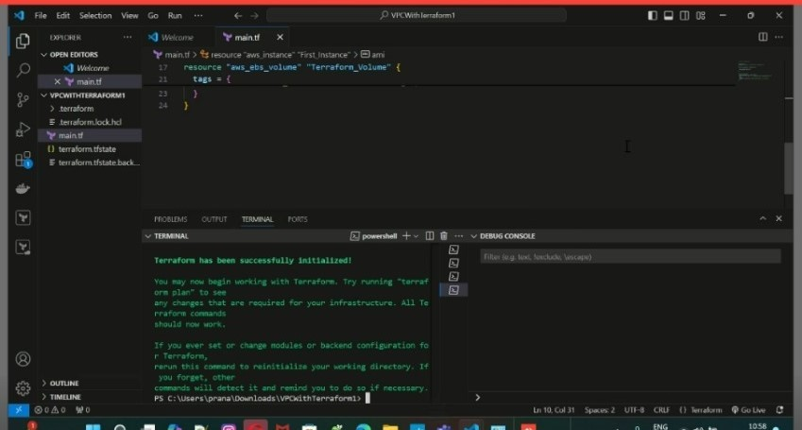

Here we will validate the necessary configuration file by using “terraform validate” command

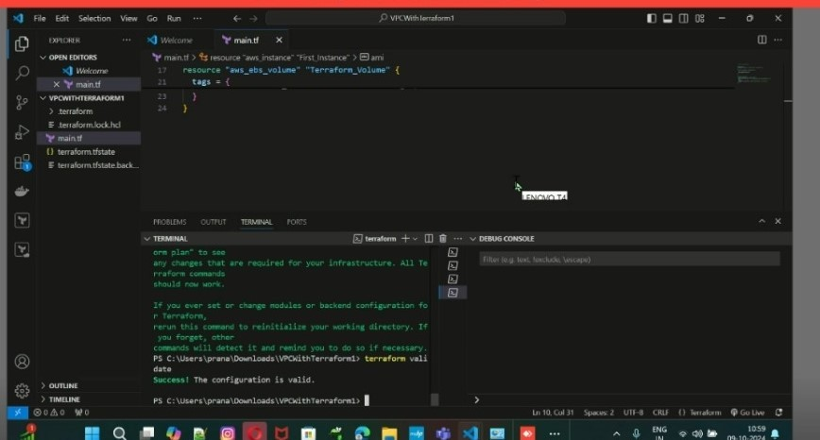

Terraform will view the changes that we make to our infrastructure before applying them by using following command “terraform plan”

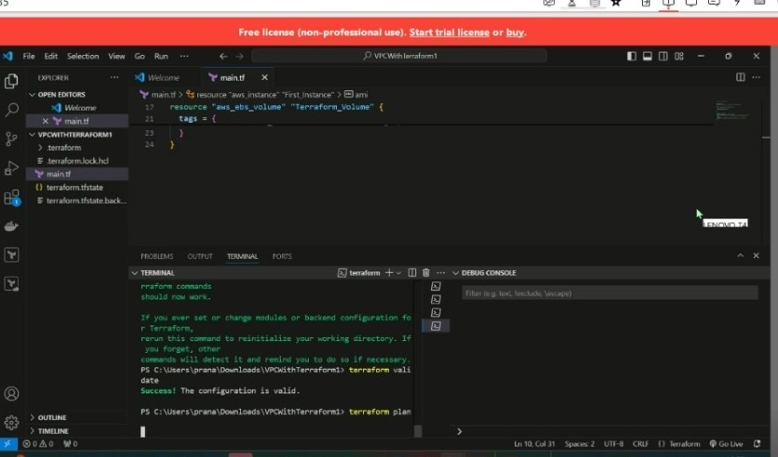

After giving this command the changes gets reflected in the console. And the command for this is “terraform apply”

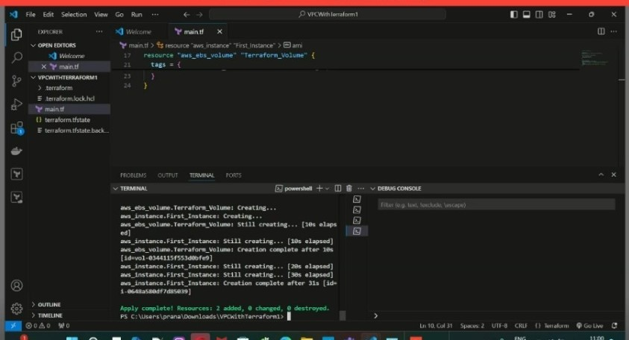

**STEP6**: EC2 instance creation with volume attached:

Here the instance will be created and the volume also will get attached automatically.

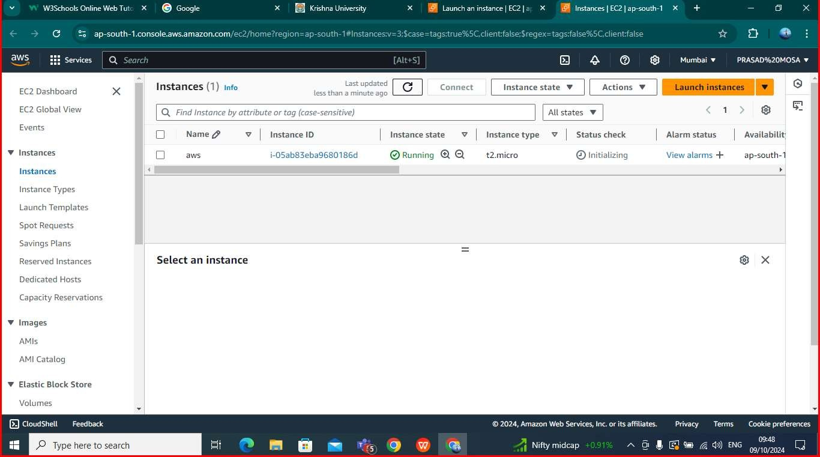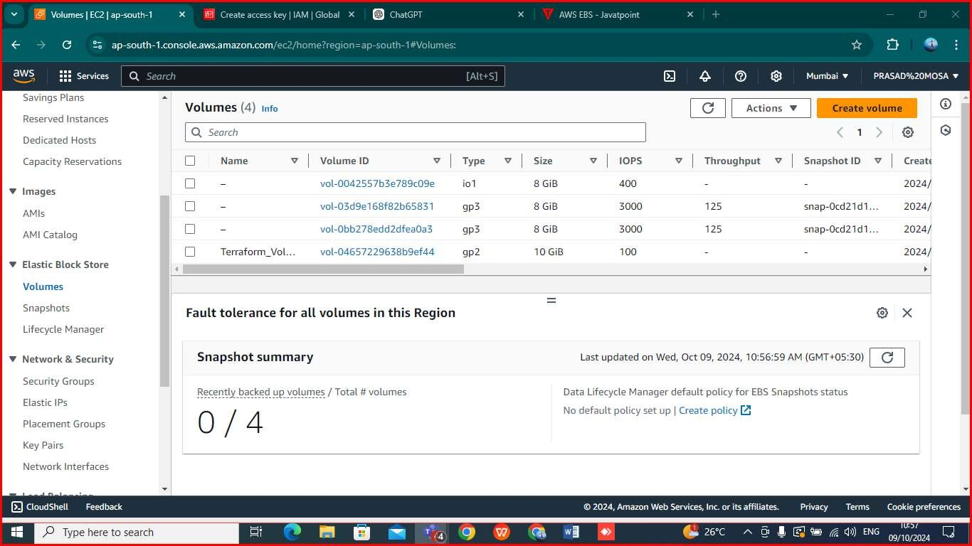

# Conclusion:

Following this steps we have created ec2 instances with ebs volumes attached